Development of Esophagus
- Caudal foregut forms fusiform dilatation (future stomach).
- Proximal to dilatation (and distal to tracheoesophageal diverticulum/septum formation) → esophagus (elongates rapidly weeks 4–8).

Development of Stomach
Caudal foregut fusiform dilatation suspended by ventral + dorsal mesogastria.

Initial: smooth lateral surfaces, sharp anterior/posterior borders.
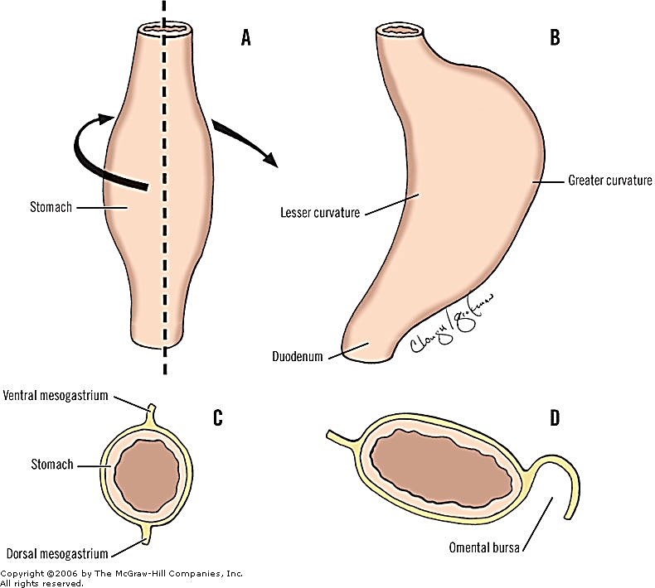

Rotation: 90° clockwise (longitudinal axis)
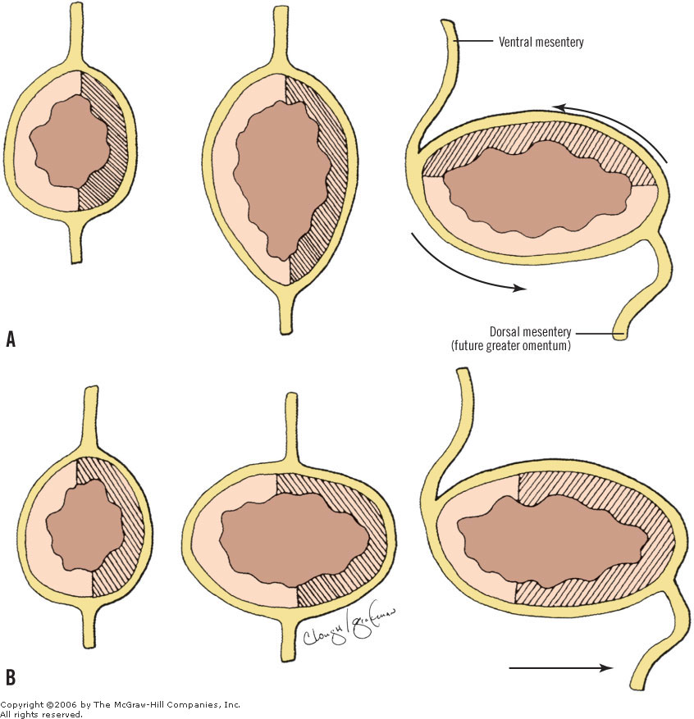
[TIP]Original posterior border → greater curvature (left), anterior border → lesser curvature (right).
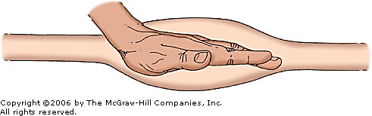
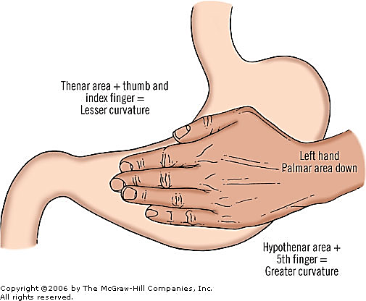
Anteroposterior shift: Cranial end → left (cardia/fundus); caudal end → right (pylorus).
Shape change: Dorsal border grows faster → greater curvature; ventral border slower → lesser curvature. Dorsal mesogastrium expands → greater omentum

Clinical Implications of Improper Stomach Development

Congenital Hypertrophic Pyloric Stenosis (IHPS)
- Most common surgical cause of GI obstruction in infants (incidence ~2–3/1000 live births, male predominance).
- Due to hypertrophy/hyperplasia of pyloric circular muscle → gastric outlet obstruction.
- Presents at 2–8 weeks with projectile non-bilious vomiting, "olive" mass on palpation, hypochloremic metabolic alkalosis.
- Requires pyloromyotomy (Ramstedt procedure).
- Untreated → severe dehydration, failure to thrive.
- Not purely a rotation defect but linked to abnormal pyloric muscle development post-rotation; associated with genetic/environmental factors (e.g., macrolide exposure in neonates increases risk).

Abnormal Gastric Rotation or Positioning
- Gastric volvulus (acute or chronic): Can occur if fixation via mesogastria is incomplete → stomach twists on axis, leading to ischemia, obstruction, Borchardt's triad (pain, retching without vomit, inability to pass NG tube). Surgical emergency (detorsion + gastropexy).
- Isolated gastric malrotation (rare, unlike midgut malrotation): May cause chronic pain or intermittent obstruction.

Links to Broader Rotation Defects
- While stomach rotation is foregut-specific, incomplete foregut/midgut coordination can contribute to malrotation spectrum (e.g., in heterotaxy).
- Midgut malrotation (more common) can indirectly affect stomach/duodenum position, leading to duodenal obstruction, volvulus (Ladd's bands), or chronic symptoms in older children/adults.

